Performance Assessment 1 – Final Review

In this lab you will be using Packet Tracer.

Your network will a class B network based on a number assigned by your professor, which you will be using for the duration of the class. In the lab anytime you see an underline you should fill in this number.

**Student network: 10.____.0.0/16**

**Using the Packet Tracer create the network below.**

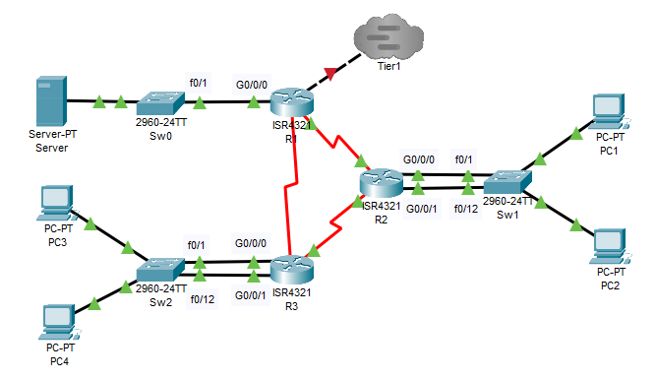

**Program your network as an IPv6 network**

Program each of your routers and switches for the above network.

|  |  |  |  |
| --- | --- | --- | --- |
| **System** | **Port** | **Connect To** | **IP address** |
| R1 | G0/0/0 | Sw0 | 2001:DB8:___:1::1/64 |
|  | G0/0/1 | Tier1 | 2001:DB8:11:1::___/64 |
|  | Se0/1/0 | R2 | FD00:0:___:7::1/64 |
|  | Se0/1/1 | R3 | FD00:0:___:9::2/64 |
| R2 | G0/0/0 | Sw1 | 2001:DB8:___:2::1/64 |
|  | G0/0/1 | Sw1 | 2001:DB8:___:3::1/64 |
|  | Se0/1/0 | R3 | FD00:0:___:8::1/64 |
|  | Se0/1/1 | R1 | FD00:0:___:7::2/64 |
| R3 | G0/0/0 | Sw2 | 2001:DB8:___:4::1/64 |
|  | G0/0/1 | Sw2 | 2001:DB8:___:5::1/64 |
|  | Se0/1/0 | R1 | FD00:0:___:9::1/64 |
|  | Se0/1/1 | R2 | FD00:0:___:8::2/64 |

Program each router as show above. An example is given to program R1.

R1(config)# ipv6 unicast-routing

R1(config)# interface g0/0/0

R1(config-if)# ipv6 enable

R1(config-if)# ipv6 address 2001:DB8:___:1::1/64

R1(config)# interface g0/0/1

R1(config-if)# ipv6 enable

R1(config-if)# ipv6 address 2001:DB8:11:1::___/64

R1(config-if)# interface s0/1/0

R1(config-if)# ipv6 enable

R1(config-if)# ipv6 address FD00:0:___:7::1/64

R1(config-if)# interface s0/1/1

R1(config-if)# ipv6 enable

R1(config-if)# ipv6 address FD00:0:___:9::2/64

You will not need to program Sw0 as it does not include VLANs.

IPv6 will not broadcast Router Advertisements (RA) information across VLANs so you must program each VLAN into its own interface on the router. Program the VLANs as shown below.

Sw1(config)#interface range f0/1-11

Sw1(config-if-range)#switchport mode access

Sw1(config-if-range)#switchport access vlan 10

Sw1(config-if-range)#interface range f0/12-24

Sw1(config-if-range)#switchport mode access

Sw1(config-if-range)#switchport access vlan 20

Sw2(config)#interface range f0/1-11

Sw2(config-if-range)#switchport mode access

Sw2(config-if-range)#switchport access vlan 10

Sw2(config-if-range)#interface range f0/12-24

Sw2(config-if-range)#switchport mode access

Sw2(config-if-range)#switchport access vlan 20

Then connect the wires from the router to the specifically programmed port of the switch.

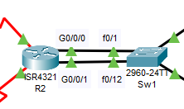

Program each of the remaining routers. Pull and IPv6 address to each PC by clicking on the Auto Config button in the IPv6 configuration.

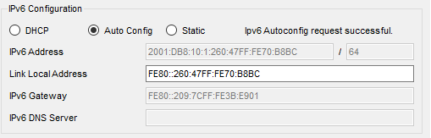

Setting up OSPFv3

Program into each router as follows

R1(config)# ipv6 router ospf 1

R1(config-rtr)# router-id 1.1.1.1

R1(config-rtr)# interface g0/0/0

R1(config-if)# ipv6 ospf 1 area 1

R1(config-rtr)# interface g0/0/1

R1(config-if)# ipv6 ospf 1 area 0

R1(config-if)# interface s0/1/0

R1(config-if)# ipv6 ospf 1 area 0

R1(config-if)# interface s0/1/1

R1(config-if)# ipv6 ospf 1 area 0

R2(config)# ipv6 router ospf 1

R2(config-rtr)# router-id 2.2.2.2

R2(config-rtr)# interface g0/0/0

R2(config-if)# ipv6 ospf 1 area 1

R2(config-rtr)# interface g0/0/1

R2(config-if)# ipv6 ospf 1 area 1

R2(config-rtr)# interface s0/1/0

R2(config-if)# ipv6 ospf 1 area 0

R2(config-if)# interface s0/1/1

R2(config-if)# ipv6 ospf 1 area 0

R3(config)# ipv6 router ospf 1

R3(config-rtr)# router-id 3.3.3.3

R2(config-rtr)# interface g0/0/0

R2(config-if)# ipv6 ospf 1 area 1

R2(config-rtr)# interface g0/0/1

R2(config-if)# ipv6 ospf 1 area 1

R3(config-if)# interface s0/1/0

R3(config-if)# ipv6 ospf 1 area 0

R3(config-if)# interface s0/1/1

R3(config-if)# ipv6 ospf 1 area 0

Verify that your OSPFv3 routing is working by using the command *show ipv6 route* on your R3 router to show the IPv6 routing table. Take a screenshot.

Go to your server and copy your IPv6 address below. You can find it on your IPv6 configuration tab or by typing **ipv6config** in a command prompt window.

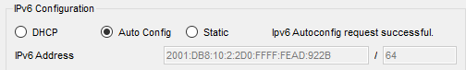

Go to your PC1 and type

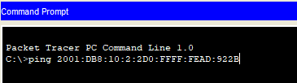

Take a screenshot of your successful IPv6 ping.

**Deliverables**

* Screenshot of your working network
* Screenshot of IPv6 routing table from R3
* Screenshot of successful IPv6 ping from PC1 to the server

PASTE SCREENSHOTS BELOW

**Task 2 – Connect to Tier1 using IPv6**

Connect your network through to the Tier1 Network and set up the Tier 1 network to run on IPv6 only.

|  |  |  |  |
| --- | --- | --- | --- |
| **System** | **Port** | **Connect To** | **IP address** |
| Tier 1 | F0/0 | Tier1Sw1 | 2001:DB8:11:1::1/64 |
|  | F0/1 | Internet | 2001:DB8:11:2::1/64 |

Connect through the cloud to your Tier1 network

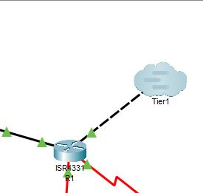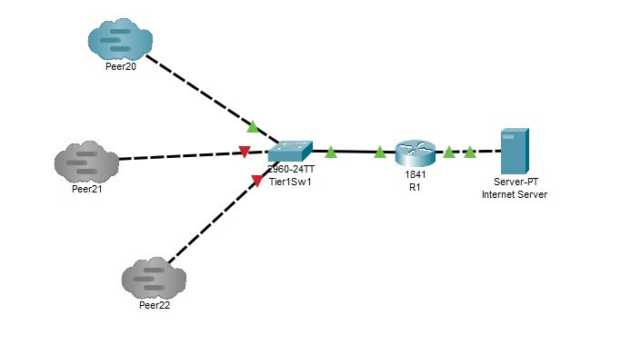

Setting up OSPFv3 on Tier1 Router

R1(config)# ipv6 router ospf 1

R1(config-rtr)# router-id 4.4.4.4

R1(config-rtr)# interface f0/0

R1(config-if)# ipv6 ospf 1 area 0

R1(config-rtr)# interface f0/1

R1(config-if)# ipv6 ospf 1 area 0

Verify that your IPv6 network is working by pulling a show ipv6 route from your R3 router. Take a screenshot.

Go to the Tier1 Internet Server and copy your IPv6 address below. You can find it on your IPv6 configuration tab or by typing **ipv6config** in a command prompt window.



Go to your PC2 and ping your Tier1 server using the IPv6 address.



Take a screenshot of your successful IPv6 ping.

**Deliverables**

* Screenshot of IPv6 routing table from R3
* Screenshot of successful IPv6 ping from PC2 to the Tier1 Internet Server

PASTE SCREENSHOTS BELOW

**Task 3 – Switch to IPv4**

Change the network to the following system.

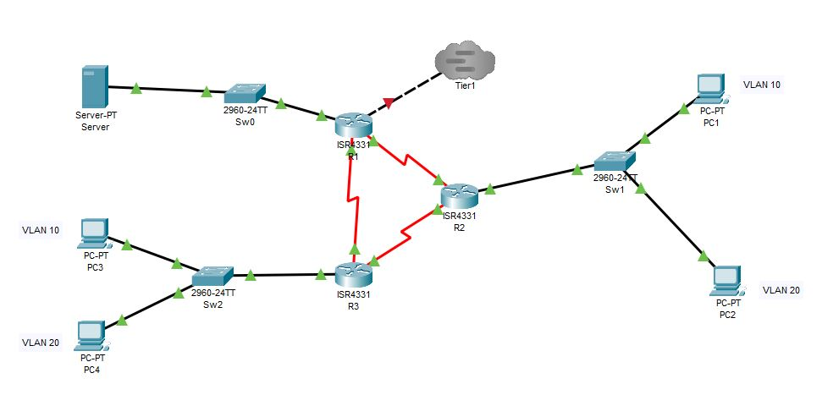

Change the programming to IPv4

|  |  |  |  |
| --- | --- | --- | --- |
| **System** | **Port** | **Connect To** | **IP address** |
| R1 | G0/0/0 | Sw0 | 10.___.1.1/24 |
|  | G0/0/1 | Tier1 | 11.0.0.___/24 |
|  | Se0/1/0 | R2 | 10.___.5.1/30 |
|  | Se0/1/1 | R3 | 10.___.5.10/30 |
| R2 | G0/0/0.10 | Sw1 | 10.___.2.1/26 |
|  | G0/0/0.20 | Sw1 | 10.___.2.65/26 |
|  | Se0/1/0 | R3 | 10.___.5.5/30 |
|  | Se0/1/1 | R1 | 10.___.5.2/30 |
| R3 | G0/0/0.10 | Sw2 | 10.___.2.129/26 |
|  | G0/0/0.20 | Sw2 | 10.___.2.193/26 |
|  | Se0/1/0 | R1 | 10.___.5.9/30 |
|  | Se0/1/1 | R2 | 10.___.5.6/30 |

Add OSPF to each router.

R1(config)#router ospf 1

R1(config-router)#network 10.___.1.0 0.0.0.255 area 1

R1(config-router)#network 11.0.0.0 0.0.0.255 area 0

R1(config-router)#network 10.___.5.0 0.0.0.3 area 0

R1(config-router)#network 10.___.5.8 0.0.0.3 area 0

R2(config)#router ospf 1

R2(config-router)#network 10.___.2.0 0.0.0.63 area 1

R2(config-router)#network 10.___.2.64 0.0.0.63 area 1

R2(config-router)#network 10.___.5.4 0.0.0.3 area 0

R2(config-router)#network 10.___.5.0 0.0.0.3 area 0

R3(config)#router ospf 1

R3(config-router)#network 10.___.2.128 0.0.0.63 area 1

R3(config-router)#network 10.___.2.192 0.0.0.63 area 1

R3(config-router)#network 10.___.5.8 0.0.0.3 area 0

Verify that your network is properly set-up by pulling a *show ip route* from the R3 router. Take a screenshot.

Set a static address for your server of 10.___.1.10/24 and a default gateway of 10.___.1.1.

Set-up DHCP on your server for all PCs on the network (four pools). Take a screenshot of each PC’s IP address using DCHP. Don’t forget to configure IP helpers on the sub-interfaces on R2 and R3 and configure the trunk ports on Sw1 and Sw2.

Pull an IP address to each PC. Ping from PC1 to PC4. Take a screenshot.

**Deliverables**

* Screenshot of show ip route from the R3 router
* Screenshot of addresses for each PC
* Screenshot of a ping from PC1 to PC4

PASTE SCREENSHOTS BELOW

**Task 4 – Add DNS to the server and SNMP to the network**

Open you DNS server on your network and add the address for server.com as 11.1.1.10. Turn the service on.

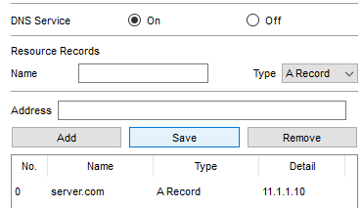

Connect to the Tier1 network and pull a webpage using the name http://11.1.1.10. Take a screenshot.

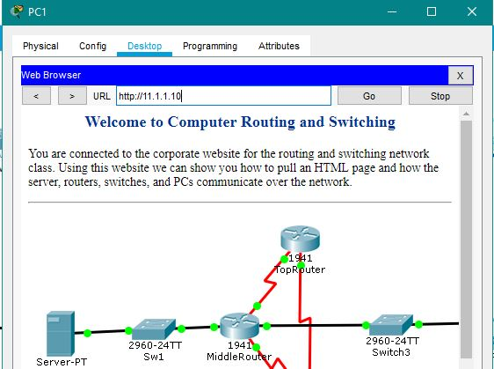

Add SNMP to each of the routers.

R1(config)# snmp-server community R1 ro

R1(config)# snmp-server community R1rw rw

R2(config)# snmp-server community R2 ro

R2(config)# snmp-server community R2rw rw

R3(config)# snmp-server community R3 ro

R3(config)# snmp-server community R3rw rw

On your server go to your desktop and open the MIB browser. Click on the advanced button and enter the following. Your read community is **R1** and your Write community is **R1rw** from the commands you entered above. Change your SNMP version to v3. Click the OK button.

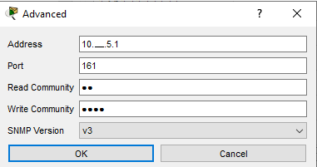

Go back to the MIB browser page and expand the MIB tree by clicking on the arrow to the left. Keep going down the menu tree until you come to .ifDescr and click on it.

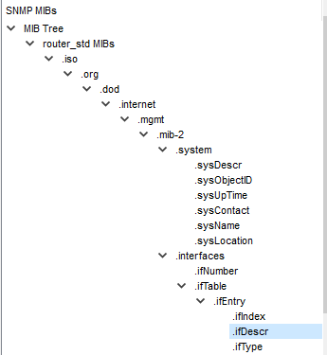

You will now see an OID at the top of the screen. Click on the GO button. Verify that your interfaces are in the MIB database. Take a screenshot.

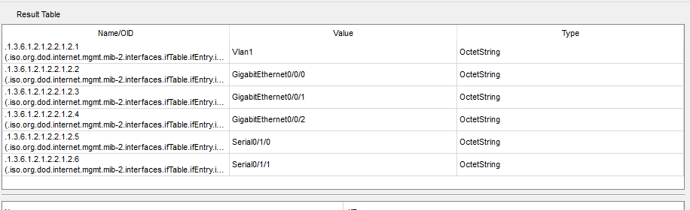

Add SNMP to each of your routers. Verify that you can see the information for R2 and R3. Take a screenshot of each.

**Deliverables**

* Screenshot of a webpage from PC1 from the Internet Server
* Screenshot of your MIB database for R1
* Screenshot of your MIB database for R2
* Screenshot of your MIB database for R3

PASTE SCREENSHOTS BELOW